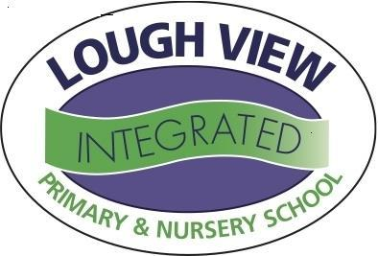

Dear Parent/Guardian,
Lough View Integrated is a school where every aspect of a child is focused on and developed, including the area of wellbeing. As part of our school’s aim to promote a happy and successful school, we have worked hard to be recognised as a “Rights Respecting School”. This is an award which is given to schools on behalf of UNICEF.
UNICEF is the world’s leading organisation working for children and their rights. In 1989, governments worldwide promised all children the same rights by adopting the UN Convention on the Rights of the Child (UNCRC). These rights are based on what a child needs to survive and grow, participate and fulfil their potential.
Being a ‘Rights Respecting School’ helps our pupils to grow into confident, caring and responsible young citizens both in school and within the wider community. By learning about their rights our pupils, your children, also learn about the importance of respecting the rights of others i.e. their responsibilities.
In nursery, our children are encouraged to reflect on how their behaviour and actions affect those around them, which allows us to build and maintain a positive and safe learning environment for all, both in our class and around the school. This is achieved through our R.R.S planning document which incorporates elements of the UNCRC.
It would be great if you could spend a few minutes reading through our planning and the articles we have chosen which we feel are best suited to nursery. We really hope you will be able to support our work to promote our ‘Rights Respecting School’.
If you would like more information about the work of UNICEF and its ‘Rights Respecting School’ programme, then please visit: www.unicef.org.uk/rrsa

Lough View Nursery is a Right’s Respecting School

Article 1&2 — We all have rights!

Adult Responsibility:
To provide stimulating and interesting play opportunities.
To enable all children to participate
Article 31
All children have the right to relax & play and to join in a wide range of activities.

Child Responsibility:
To play in such a way that it does not stop others from playing.
Adult Responsibility:
To ensure that the curriculum is interactive, experiential and accessible for all.

Article 28 & 29
Every child has the right to an education which develops the whole child and fosters respect.

Child Responsibility:
To enjoy, learn and participate fully in nursery life.
Adult Responsibility:
To teach children about staying healthy and living a healthy lifestyle.

Article 24
Children have the right to be healthy.
Child Responsibility:
To understand how to stay healthy.
Adult Responsibility:
To keep our children safe and secure in this environment and protect them from harm.

Article 19
Children should be protected from harm from all who look after them.
Child Responsibility:
To feel safe, secure, loved and cared for.
Adult Responsibility:
To listen and respect the views of each child and model good speaking and listening to others.

Child Responsibility:
To listen to others, voice their opinion and ask for help when they need it.
Article 12 & 13
Every child has the right to speak, to be heard and to have their views taken seriously.

Adult Responsibility:
To use every child’s name and pronounce and spell it correctly.
Article 7
Every child has the right to a name.
Child Responsibility:
To learn the names of adults and children and use them.
Adult Responsibility:
To ensure that our children are central in everything we do.
Article 3
The best interests of the child will be our top priority.
Child Responsibility:
To understand that they are valued members of our nursery.

